Shivagadhi English School
Supplementary Examination- 2081
Class: 8 Subject: Maths F.M: 50
Time: 2 Hrs. Set "A" P.M:20

- The subsets of universal set U= {whole number less than 7} are
P={even numbers less than 7} and Q={prime numbers less than 7}
    - Define overlapping set. (1)
    - Write the elements of P and Q. (1)
    - Show that above information in venn diagram. (1)
- Manoj pays a simple interest of Rs. 24000 for loan taken for 3 years
at rate of 10% p.a.
    - In simple interest what is the relation of A, P and I. (1)
    - How much loan he had taken. (2)
    - How much did he pay to clear the loan. (1)
- The MP of a watch is Rs. 2000 if shopkeeper allows 15% discount
in it, then.
    - Write the formula to find the discount percent if discount
amount and marked price are given. (1)
    - Find the discount amount in the watch. (1)
    - Find the profit or loss of shopkeeper if he had bought
the watch with Rs. 1500. (2)
- A water tank can hold 213200 litres of water.
    - Write the capacity of the water tank in scientific notation. (1)
    - Convert 1.22 into fraction. (1)
    - In a game, Raman got (100011)₂ points and Ishan got (123)₅.
The player with highest point is the winner who is winner?
Find it. (2)
- a) Write the expanded form of : (𝑥+2)² (1)
  - Simplify: ${\left(x^{2}y÷{xy}^{3}\right)}^{3}$ (1)
  - Factorize: 𝑥²−16 (2)

- Purnima has planed to deposit Rs. 200000 in the ratio of 3:2 to
Bank A and B.
  - How much amount did she deposit in Bank A and B. (2)

b.If Bank A gives 5% per annum interest and Bank B gives 6% per annum interest then find the interest received form bank A. (2)
c.Find the difference of interest given by bank A and B. (1)
- The trapezium shaped land shown in the figure belongs to Radha, inside the land there is a pond in the shape of square.
    - Write the formula to find the area of trapezium. (1)
    - Find the area of the surface of the pond. (2)
    - Find the area of land excluding the pond. (2)
    - How much wire required to fence the two rounds? Calculate it. (1)
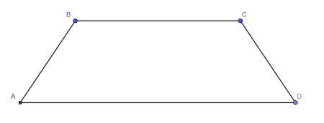

20
c
m
15
c
m
14
c
m
30
c
m
12
c
m
4
c
m
- Nambina and sabina create circular garden with a 20m and 48m radius, respectively. Rabina also construct the circular garden whose size is equals the total of the area of the circle constructed by Sabina and Nabina.
    - Find the area of the circle made by Nabina. (1)
    - Find the area of the circle made by Sabina. (1)
    - Find the area of circle made by Rabina. (2)
- a) Define direct and indirect variation. (2)
  - 5 men require 10 days to construct a wall how many days would it take for 4 men. To complete the same work. (2)
- a) find a:b:c, if a:b=3:4 and b:c=2:5. (2)
  - Divide Rs. 125 in the ratio of 1:4. (2)
- a) Define isosceles triangle. (1)
  - What is the area of given figure. (2)
  - Find the perimeter of given figure. (1)
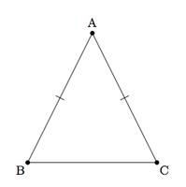
5
c
m
6
c
m
12. a) Find the HCF & LCM of : (2)
$\left(abx+3ab\right) and {ab}^{2}\left(x^{2}-9\right)$
b) Simplify : $\frac{a}{x^{2}-x}+\frac{a}{x^{2}-x^{3}}$ (2) The End

